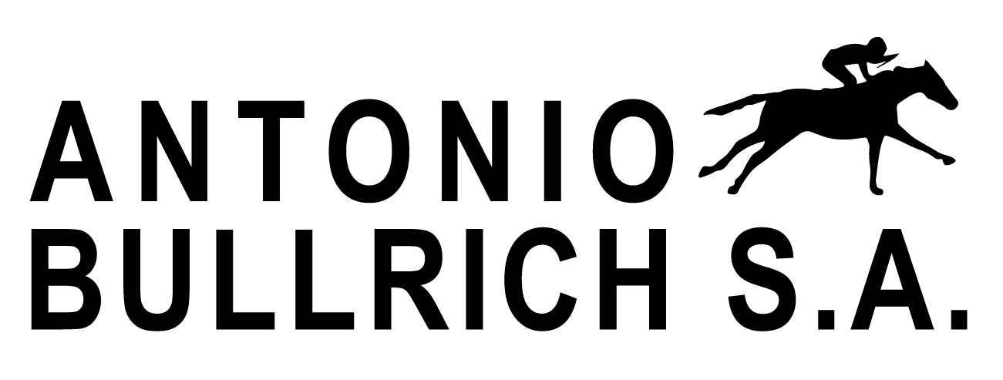
CONTACT INFORMATION
Antonio Bullrich S.A.
(+54911) 51747274
antoniobullrich@antoniobullrich.com

RELEASE DATE:
Wednesday 3rd, 2020

COPA JUNIO SALE

A prominent group of yearlings will be presented online and live by Firmamento, La Pasion, Santa Ines, Carampangue, El Mallin, Don Yayo and La Pomme farms.

BUENOS AIRES, ARGENTINA / The prestigious and traditional argentine breeding operations; Firmamento, La Pasión, Santa Ines, Carampangue, El Mallin, Don Yayo and La Pomme, will begin their online COPA JUNIO sale on Tuesday June 16th at www.antoniobullrich.com.

Online bidding is possible for every horse listed in the catalogue until Tuesday June 23rd.

On Wednesday June 24th, the sale will end with a live auction streamed online from La Pasión Stud Farm. The live auction shall begin recognizing the first live bid as being winning bid from the online auction. Phone bidding will be available during the live sale phase, and a special 10 percent discount will be applied to the lot if the winning bidder of the online auction is the winning bidder during the live portion.

All horses can be ocular inspected live by appointment only.

Online Sale:
- Start: Tuesday June 16th until Tuesday June 23th (only online bidding)
- Finish: Wednesday June 24th at 12pm, live auction streamed online (only phone bidding)

###

